PREDICTIVE ANALYTICS
PROJECT REPORT
(Project Semester October-December 2025)

“Air Quality Prediction & Analysis System”

Submitted by

Abhik Konar

Registration No.12306328

Programme and Section: -B. Tech in CSE (K23BG)
Course Code INT234

Under the Guidance of
Dr. Gargi Sharma (UID:29439)

Discipline of CSE/IT

School of Computer Science & Engineering
Lovely Professional University, Phagwara

CERTIFICATE

- This is to certify that Abhik Konar bearing Registration no. 12306328 has completed INT234 project titled, “Air Quality Prediction & Analysis System” under my guidance and supervision. To the best of my knowledge, the present work is the result of his/her original development, effort and study.

Dr. Gargi Sharma
Assistant Professor
School of Computer Science & Engineering
Lovely Professional University
Phagwara, Punjab.

Date: 18.12.2025

DECLARATION

I, Abhik Konar, student of B. Tech in Computer Science & Engineering under CSE/IT Discipline at, Lovely Professional University, Punjab, hereby declare that all the information furnished in this project report is based on my own intensive work and is genuine.

Date: 18.12.2025 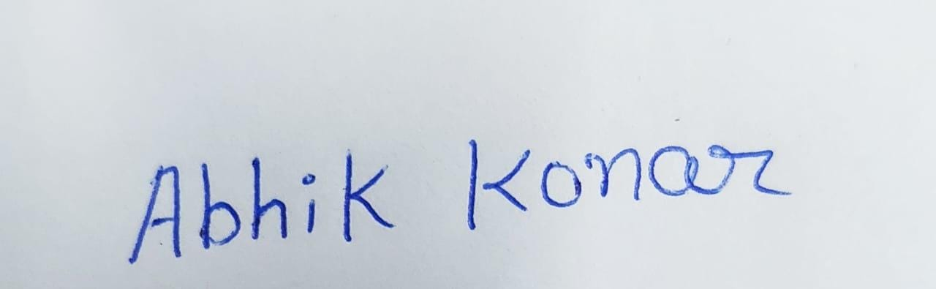
Registration No. 12306328 Abhik Konar

ACKNOWLEDGEMENT

I would like to take a moment to sincerely thank everyone who helped me throughout this project. Without their support, this wouldn’t have been possible.
First, I’m truly grateful to my faculty, Dr. Gargi Sharma, for their continuous guidance and encouragement. Her support kept me focused and motivated from the very beginning.
I’d also like to thank my friends and classmates who shared their thoughts and gave me helpful feedback along the way — it really made a difference.
Working on this project was a great experience for me, and I’ve learned so much.

Table of Content

1. Introduction
2. Source of dataset
3. Dataset Preprocessing
4. Analysis on dataset (for each objective)
- General Description
- Specific Requirements
- Analysis results
- Visualization
5.Prediction Result
6. Conclusion
7. Future scope
8. References

1.INTRODUCTION: -
The Air Quality Prediction & Analysis System is an intelligent machine learning–driven solution designed to monitor, analyze, and predict air pollution levels with high accuracy. As environmental pollution becomes a growing global concern, the need for reliable and automated air quality assessment tools has increased significantly. This system leverages real-world air sensor data—such as humidity, temperature, pressure, VOC levels, and particulate matter (PM1, PM10, PM2.5)—to evaluate atmospheric conditions and forecast pollution levels.
Using advanced preprocessing techniques and multiple supervised learning models, the system predicts PM2.5 concentration through regression and categorizes overall air quality as “Good” or “Poor” using classification algorithms. The integration of trained models into a Flask web application allows users to input environmental parameters and receive real-time predictions through an interactive and user-friendly interface.

2.Source Of Dataset: -
Link: https://catalog.data.gov/dataset/air-quality-purple-air-sensors

Screenshot: -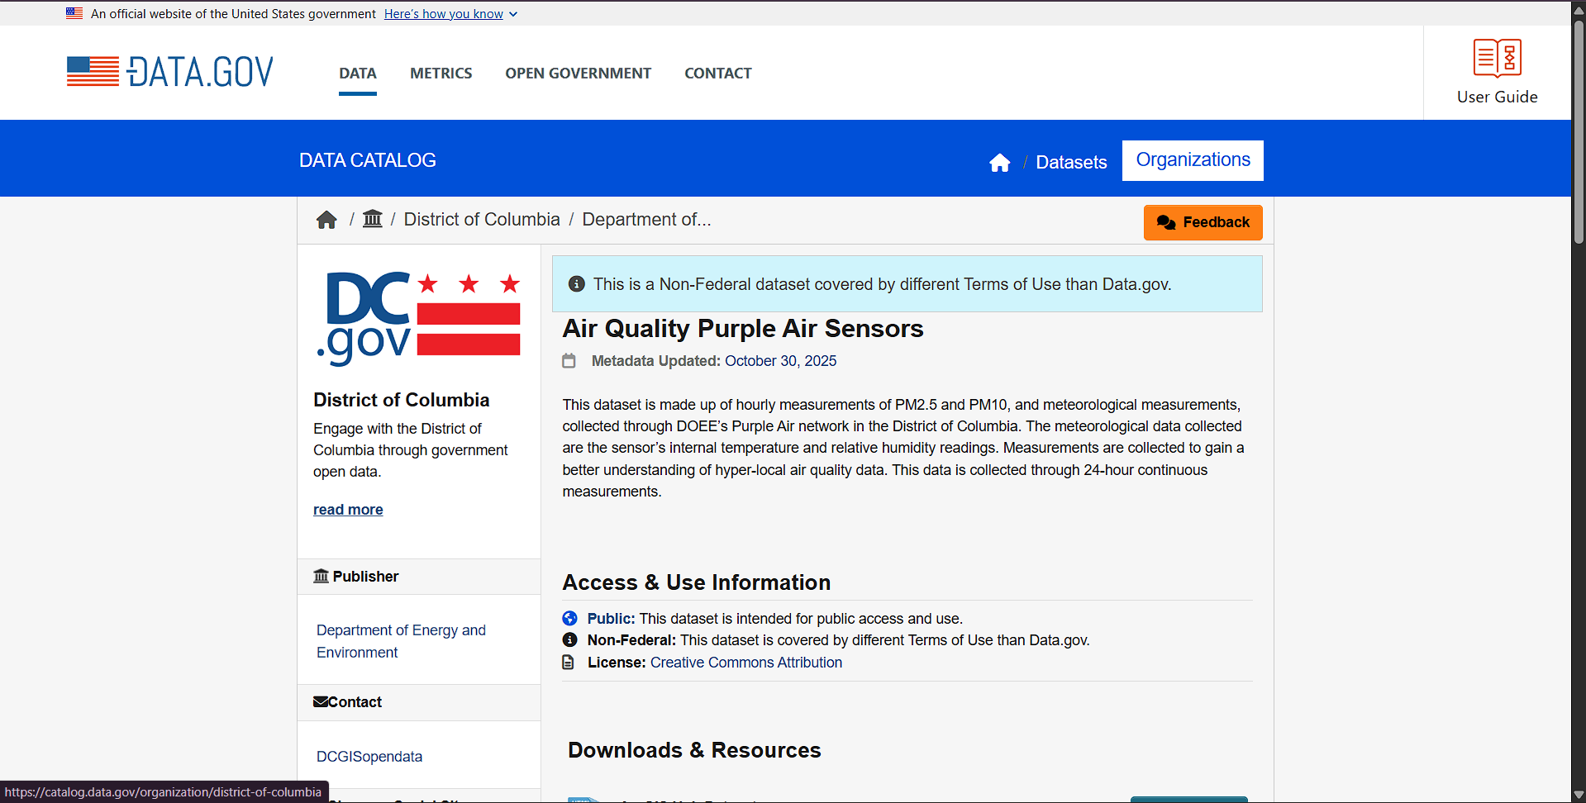

3.Dataset Preprocessing: -
Dataset preprocessing is a critical step to ensure the reliability and accuracy of machine learning models. The Air Quality Prediction & Analysis System uses the Air Quality PurpleAir Sensors Dataset, which contains various environmental sensor readings such as humidity, temperature, pressure, particulate matter (PM1, PM10, PM2.5), VOC concentration, and geolocation details. Before modeling, several preprocessing operations were performed to clean and transform the raw dataset into a structured and usable format.
1. Handling Missing Values
The dataset contained missing values in several sensor columns. To avoid model bias and preserve dataset size, appropriate imputation strategies were applied:
- Mean Imputation:
Used for HUMIDITY, PM1, PM2.5, PM10, PM2_5_CF_1, PM2_5_ALT.
This is suitable for continuous variables with near-normal distribution.
- Median Imputation:
Applied to TEMPERATURE, PRESSURE, CONFIDENCE, VOC.
This helps reduce the impact of outliers.

2. Date-Time Feature Engineering
The REPORTED_DATETIME column was converted into structured time-based features:
- HOUR
- MONTH
- DAY_OF_WEEK
- IS_WEEKEND (1 = Saturday/Sunday, otherwise 0)
- Extracted geographic patterns using:
LAT_ROUND and LON_ROUND (latitude/longitude rounded to 2 decimals)

4.Analysis on dataset: -

Objective 1: PM2.5 Concentration Prediction (Regression Analysis)

i. General Description
This objective focuses on predicting PM2.5 concentration levels using environmental and temporal features collected from PurpleAir sensors. PM2.5 is a critical air pollutant that directly impacts human health. Regression techniques are applied to model the relationship between PM2.5 and influencing factors such as humidity, temperature, pressure, particulate matter (PM1, PM10), VOC levels, time-based attributes, and geographic location.
ii. Specific Requirements
- Input features: Humidity, Temperature, Pressure, PM1, PM10, VOC, Hour, Month, Day of Week, Weekend indicator, Latitude, Longitude
- Target variable: PM2.5
- Data preprocessing: Missing value imputation, datetime feature extraction, feature scaling using StandardScaler
- Models used: Linear Regression, Ridge, Lasso, KNN Regressor, Decision Tree Regressor, Random Forest Regressor, Gradient Boosting Regressor
- Evaluation metrics: MAE, MSE, RMSE

iii. Analysis Results
Among all regression models, Random Forest Regressor and Gradient Boosting Regressor demonstrated superior performance with lower MAE and RMSE values, indicating better handling of non-linear relationships in air quality data. Linear models showed comparatively higher error, suggesting that PM2.5 is influenced by complex interactions rather than simple linear patterns.

iv. Visualization
Scatter plot comparing Actual vs Predicted PM2.5 values
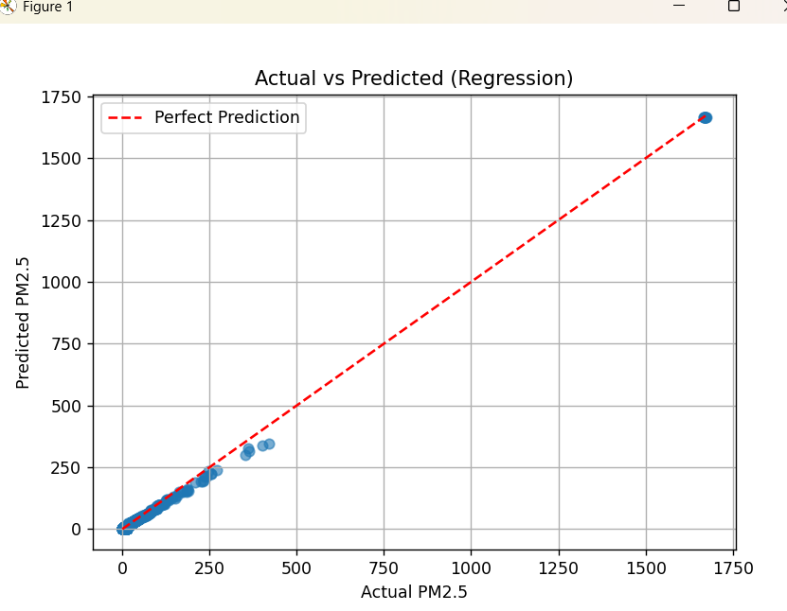

Objective 2: Air Quality Classification (Good vs Poor Air Quality)
i. General Description
This objective classifies air quality into Good (0) or Poor (1) categories based on PM2.5 thresholds. If PM2.5 exceeds 50, the air quality is labeled as poor. Classification helps in early warning systems and decision-making for public health interventions.
ii. Specific Requirements
- Target variable: Binary Air Quality Label
- Threshold-based labeling from PM2.5 values
- Models used: Logistic Regression, KNN Classifier, Decision Tree Classifier, Random Forest Classifier, Gradient Boosting Classifier, AdaBoost Classifier
- Evaluation metrics: Accuracy, Precision, Recall, F1-score

iii. Analysis Results
The Random Forest Classifier achieved the highest accuracy and F1-score, demonstrating strong generalization and balanced classification performance. Logistic Regression performed adequately but struggled with complex boundaries. Ensemble models consistently outperformed individual classifiers.
iv. Visualization
Confusion Matrix heatmap for the best-performing classifier
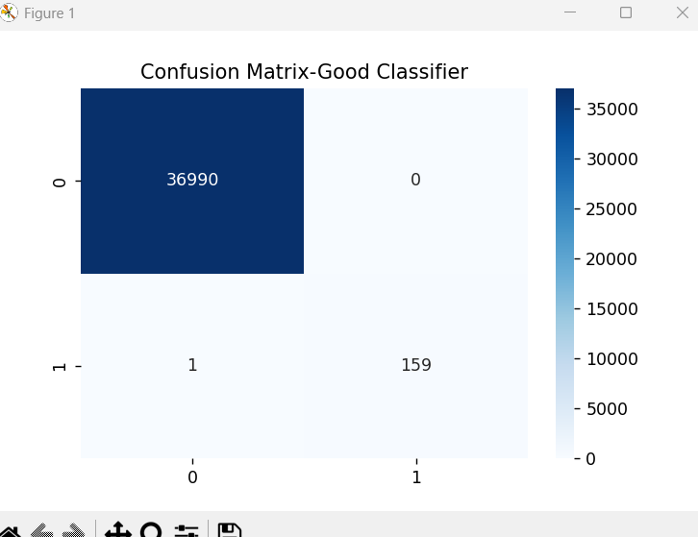

Bar chart comparing accuracy across classification models
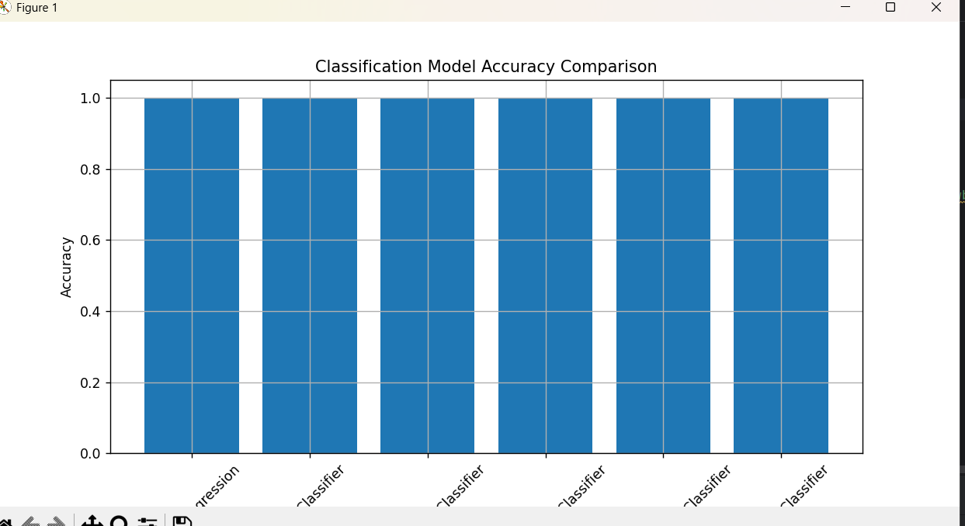

Scatter plot showing actual vs predicted class labels
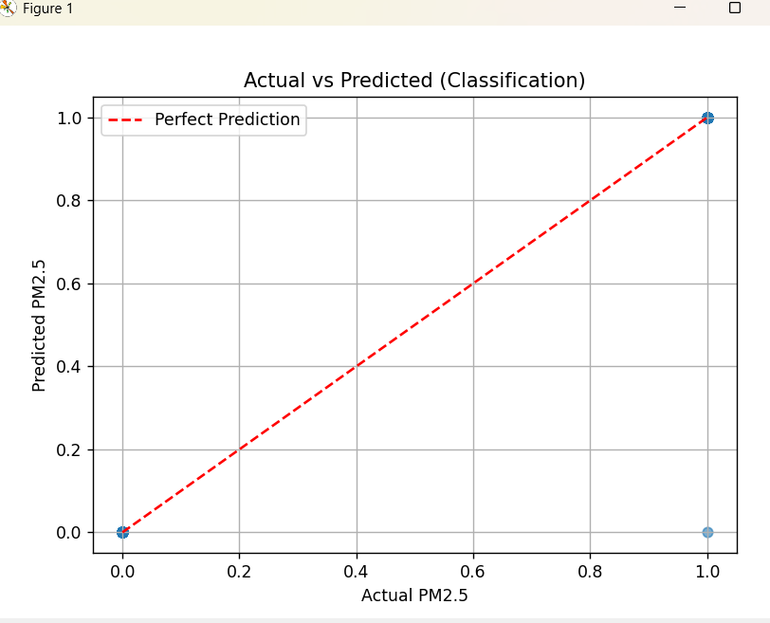

5.Prediction Result:-
Regression Model--
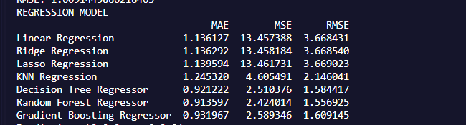
Classification Model—
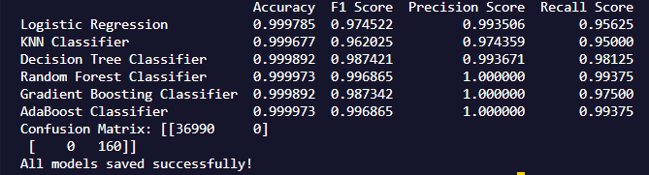

6.Conclusion: -
This project successfully demonstrated the use of supervised machine learning techniques for air quality prediction and classification using PurpleAir sensor data. After effective data preprocessing, feature engineering, and handling of missing values, multiple regression and classification models were trained and evaluated. Among the regression models, ensemble-based approaches such as Random Forest and Gradient Boosting showed superior performance in predicting PM2.5 concentrations, while Random Forest Classifier achieved strong accuracy in categorizing air quality levels. Overall, the results highlight the effectiveness of machine learning in analyzing environmental data and provide a reliable foundation for real-time air quality monitoring and decision-making systems.

7.Future Scope: -
The current system can be further enhanced by integrating real-time air quality data streams from IoT-enabled sensors, enabling continuous monitoring and instant prediction updates. Incorporating advanced time-series and deep learning models such as LSTM or GRU can improve long-term forecasting accuracy by capturing temporal dependencies in air pollution trends. The inclusion of additional meteorological and external factors such as wind speed, rainfall, traffic density, and industrial activity can significantly enhance model robustness and prediction reliability. Furthermore, the project can be extended into a full-scale web or mobile application with interactive dashboards and alert mechanisms to notify users and authorities during hazardous air quality conditions. Scaling the solution across multiple geographic regions will support smart city initiatives and assist policymakers in data-driven environmental planning and pollution control strategies.

8.References: -
- PurpleAir — PurpleAir Sensor Data (Data.gov / PurpleAir): https://www.purpleair.com/ (and dataset pages on data.gov).
- Pedregosa, F., et al., “Scikit-learn: Machine Learning in Python,” JMLR, 2011.
- Géron, A., Hands-On Machine Learning with Scikit-Learn, Keras, and TensorFlow, O’Reilly, 2019.
- Molnar, C., Interpretable Machine Learning, 2020 (for SHAP/LIME).
- Flask Documentation — https://flask.palletsprojects.com/
- Matplotlib & Seaborn docs — https://matplotlib.org/ and https://seaborn.pydata.org/

LinkedIn:-
https://www.linkedin.com/feed/update/urn:li:activity:7403871533485547520/

Github:- https://github.com/abhikkonar05/Air-Quality-Prediction-Analysis-System
